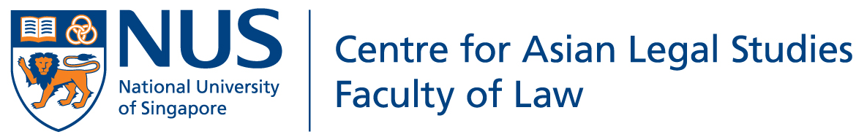

Islam, Law and the State in Myanmar

Conference 2014
23 to 24 January 2014, Faculty of Law, National University of Singapore

ABSTRACT SUBMISSION FORM

PERSONAL PARTICULARS (Please print in Block Letters)
Asst Prof / Dr / Mr / Mrs / Ms *  *Delete where appropriate and underline Surname / Family Name |  | Designation / Academic Post:
Name of Institution / Organisation:
Address of Institution / Organisation: |  | Country:
E-Mail Address: | Telephone No: ( ) | Fax No: ( )
TITLE OF PROPOSED PAPER
ABSTRACT (not more than 500 words) :
BRIEF BIOGRAPHICAL DESCRIPTION
please provide in one paragraph a brief description of your affiliation, relevant experience, qualifications,
significant publications and presentations etc. in no more than 150 words
NOTES:
1. The deadline for submission of abstracts is 20 June 2013. Please submit abstracts via email to cals@nus.edu.sg

2. You can expect to be notified via email once your abstract has been received for consideration. If your abstract is accepted, you will be informed by email by the 20 July 2013. Please maintain a functional email address at all times.

3. Upon acceptance of abstracts, full papers must be submitted by 5 January 2014. Failure to submit a paper will preclude participation.

